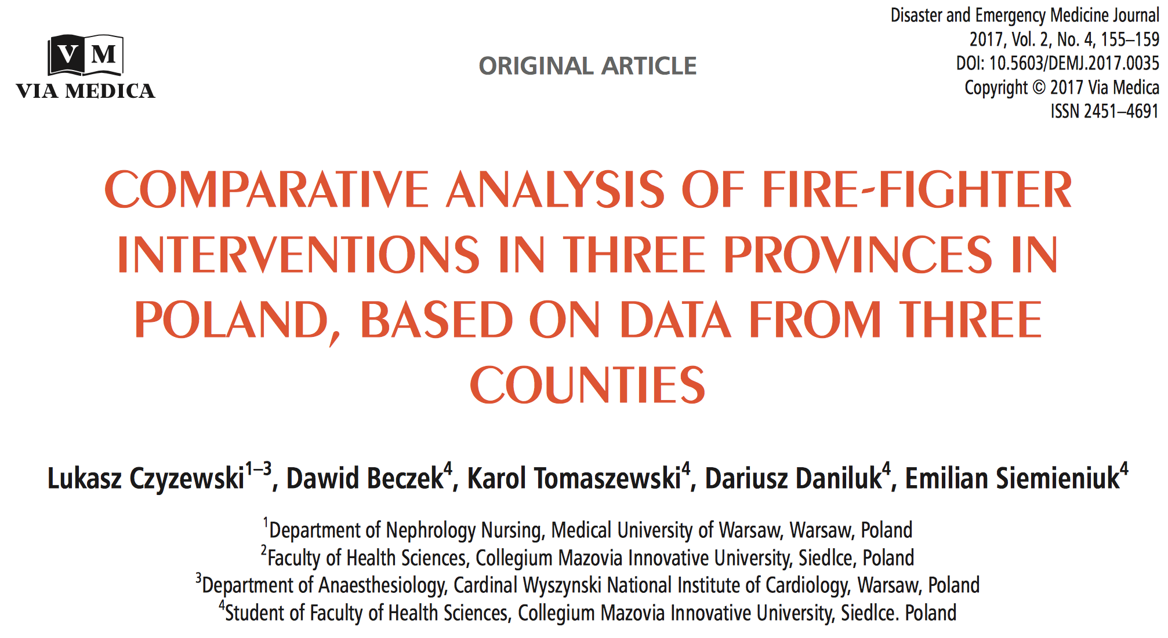
https://journals.viamedica.pl/disaster_and_emergency_medicine/article/view/DEMJ.2017.0035/43526

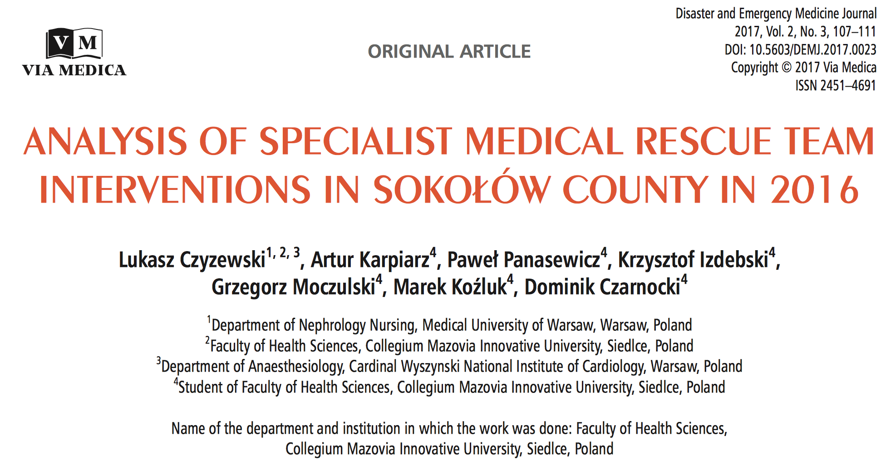
https://journals.viamedica.pl/disaster_and_emergency_medicine/article/view/DEMJ.2017.0023/41877

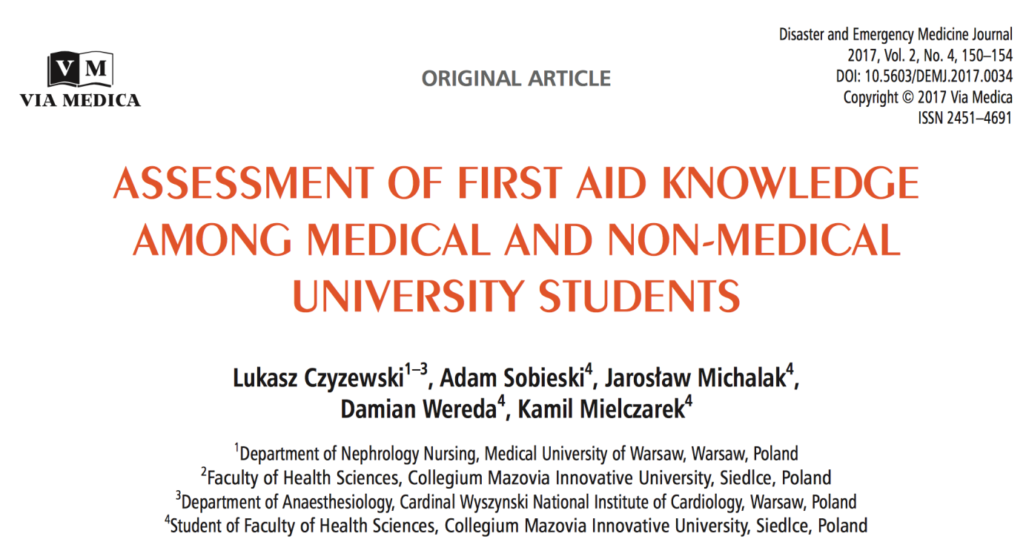

https://journals.viamedica.pl/disaster_and_emergency_medicine/article/view/DEMJ.2017.0034/43525

